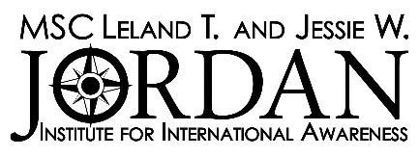
2022-2023 Internship and Living Abroad Program Recommendation Form

Please submit one copy of your remarks in a sealed and signed envelope to the MSC Leland T. and Jessie W. Jordan Institute, 1237-TAMU, College Station, TX. 77843-1237 or email jiwork@msc.tamu.edu
Form must be received by 5:00 pm Friday, October 28th, 2022

THIS SECTION TO BE COMPLETED BY APPLICANT

Name of Applicant
Classification
Reference requested from
(Name) (Position)

(Institution) (Phone Number)

THIS SECTION TO BE COMPLETED BY REFERENCE

- This recommendation is prepared with the understanding that my comments will be held in confidence. Yes  No 
- How long and in what capacity have you known the applicant?

For sections 3 and 4, please keep in mind that the applicant will be representing the United States as well as Texas A&M University and that personal suitability and academic excellence are important criteria to be considered.

- Please indicate your judgment of the applicant's professional ability and competence below.

(Please check one for each category) | Outstanding | Very Good | Average | Below Average | Inadequate Basis for Judgment
General Knowledge
Intellectual Ability
Maturity/Stability
Judgment/Problem-Solving
Oral Communication
Written Communication
Independence/Self-Direction
Motivation/Commitment
Creativity/Originality
Flexibility/Adaptability
Self-Reliance
Impression of Citizenship

- Final Overall Rating of Student (Check one.)

☐ Exceptional | ☐ Very Good | ☐ Above Average
☐ Average | ☐ Fair | ☐ Not Recommended

Signature of Reference: | Date:

