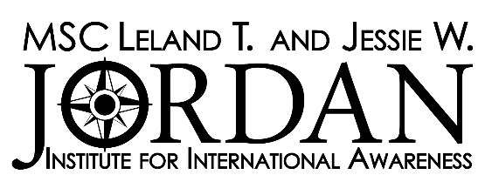
2022-2023 Fellows Program Recommendation Form

Please submit one copy of these remarks in a sealed and signed envelope to the MSC Leland T. and Jessie W. Jordan Institute, Room 2293 in the Memorial Student Center, mailstop 1237 or email jiwork@msc.tamu.edu by 5p.m. on October 27th, 2022.

THIS SECTION IS TO BE COMPLETED BY THE APPLICANT

Name of Applicant:
Classification: | UIN:
Name of Reference:

THIS SECTION IS TO BE COMPLETED BY THE REFERENCE

- How long and in what capacity have you known the applicant?

For sections 2 and 3, please keep in mind that the applicant will be representing the United States as well as Texas A&M University and that both personal suitability and academic excellence are important criteria to be considered.

- Please indicate your judgement of the applicant's professional ability and competence below.

(Select one for each category)

 | Outstanding | Very Good | Average | Below Average | Inadequate Basis for Judgement
General Knowledge
Intellectual Ability
Maturity/Stability
Judgement/Problem-Solving
Oral Communication
Written Communication
Independence/Self-Direction
Motivation/Commitment
Creativity/Originality
Flexibility/Adaptability

- Overall Rating of Student (Check one):

☐ Exceptional | ☐ Very Good | ☐ Above Average
☐ Average | ☐ Fair | ☐ Not Recommended

Signature of Reference: | Date:

